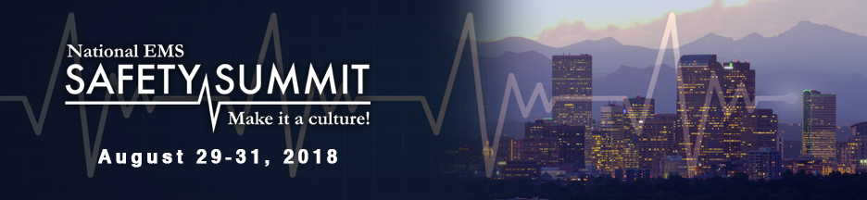

***National EMS Safety Summit***

***Embassy Suites by Hilton- Denver Downtown Convention Center***

***1420 Stout St., Denver, Colorado 80202***

***Silverton Ballroom***

***August 29-31, 2018***

***Exhibitor/Vendor Agreement***

**Contract of Agreement for Exhibitor/Vendor Space**

Company, Agency or Organization: ____________________________________

On-Site Authorized Representative: ________________________________________________________________

E-Mail Address: ___________________________________________________

Cell Phone: ______________________________________________________

This signed document indicates that the undersigned, representing the agency listed, requests the reservation of an exhibit space(s), which consists of a 3’ x 8’ table (draped and skirted) in a 10’ X 10’ booth with two chairs.

Please describe any exhibit materials and merchandise that the Exhibitor will place in the assigned space.

________________________________________________________________

________________________________________________________________

The Exhibitor/Vendor agrees to abide by the move-in and move-out times as specified by the Exhibitor/Vendor Overview.

The Summit, MHRETAC or anyone associated with the MHRETAC is not responsible for damage from accident, theft or other such causes to Exhibitor’s/Vendor’s property. The Exhibitor/Vendor is responsible for carrying any desired insurance at the Exhibitor/Vendor expense.

**Payments**

Payments must be received by **June 15, 2018**. For payment arrangements or questions please contact Shirley Terry at 303.919.0719 or [shirleyterry@comcast.net](mailto:shirleyterry@comcast.net). Checks or credit cards are accepted. **No REFUNDS after July 15, 2018.** Pay online or complete the National EMS Safety Summit Credit Card Authorization Form and send to Shirley Terry.

**Electrical Needs**

110—Yes______ No____

Please indicate if you need more than one electrical outlet. Please bring extension cords if you have them.

**Notebook Information**

A conference notebook featuring all Summit Exhibitors/Vendors will be distributed to all Summit participants. To be included in this notebook, this Agreement as well as the **Notebook information must be completed and submitted to Shirley Terry by June 15, 2018.**

Please print or type the following information that will appear in the Exhibitor/ Vendor Notebook that will be distributed to all Summit participants.

Name of Company: ________________________________________________

Name(s) and title(s) of Representatives: ________________________________________________________________

________________________________________________________________

Address: _________________________________________________________

City, State & Zip: ________________________________________________________________

Office: (______) ________________________Cell: (_______)_____________

E-mail: __________________________________________________________

Notebook Information-limit to 75 words or less: (You may e-mail this to Shirley)

________________________________________________________________

________________________________________________________________

________________________________________________________________

________________________________________________________________

Please send your **company logo in word format** via e-mail to Shirley Terry.

**Sponsorship Opportunities**

Please see the Exhibitor/Vendor Overview for sponsorship opportunities. Sponsorships will allow the National EMS Safety Summit to provide additional services and a more diverse curriculum to the EMS community. These sponsorships are invaluable and your participation in this summit is much appreciated.

**Notebook Advertisement**

Full page advertisements are available for $600, ($700 June 16 and after) and will be placed in the National EMS Safety Summit Conference participant’s notebooks. Please send via e-mail your companies advertisement for inclusion in the notebooks to Shirley Terry as listed below.

Name of Company: ________________________________________________

Name(s) and title(s) of Representatives on Site: ________________________________________________________________

________________________________________________________________

Address: _________________________________________________________

City, State & Zip:___________________________________________________

Office: (_____)__________________ Cell: (_____)______________________

E-mail: __________________________________________________________

­­­­­­­­­­­­­­­­­­­­­­Please return the **advertisement by June 15, 2018 in word format via e-mail to shirleyterry@comcast.net**

